**Annexure A – Scope of Works**

EXECUTIVE SUMMARY

*Basco Paints, the leading Paints brand out of East Africa wishes to design and develop an advanced and seamless paint visualization experience suite that caters to each segment of the smartphone users of Kenya.*

*This proposal outlines the various components, features, timeline and deliverables of such an experience suite.*

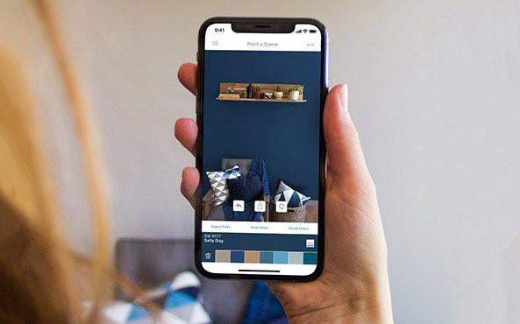

PROJECT REQUIREMENTS



AR EXPERIENCE ADVANCED DEPTH TRACKING

EXPERIENCE FOR EVERY SMARTPHONE USER

Immersive AR Experience that lets the user visualize the

products in their environment in with highly realistic graphics.

For smartphones that support ARKit and AR Core level AR Experiences, the application shall deliver a seamless visualization that has depth based occlusion.

The application shall identify the specifications of the phone and shall load an experience that is seamless for that specifications.

For smartphones that do not support ARKit and AR Core level AR Experiences, the application shall deliver a visualizer experience using just the RGB Camera feed.



ANALYTICS

MULTILINGUAL

MULTIPLATFORM

The application shall generate data on the application sessions and user behaviour for the marketing team of Basco to better understand the customer experience.

The application shall support Swahili and English languages and shall support expansion to more languages as and when required.

The application shall support both Android as well as iOS device

## Objec

Objective

The purpose of the work order is to develop a mobile application and supporting data handling systems and analytics modules to enable the users to visualize the paint products of Basco from the comfort of their home using powerful Augmented Reality technology.

Solution Suite Components Overview

1. User Application
2. Admin Dashboard
3. VR Showroom

Solution Suite Components Detail

* 1. User Application
     1. Platform – iOS and Android
     2. User – End Customer
     3. Feature List
        1. -Splash Screen
        2. -Login
           1. -Social Media Login
           2. –Phone Number / Email SignUp

OTP to login

* + - * 1. -Guest User
      1. -Select Language
         1. English
         2. Swahili
      2. -Quick App UI Tour
      3. -Inspiration Feed
         1. Combos

-Image Gallery

-Text Content

-Colours Included

-Try Combo

-Goes to Visualizer

* + - 1. Go to Visualizer
         1. -Select Wall
         2. -Select Colour / Texture

Add Selection to Palette for quick view

* + - * 1. –Visualize
        2. -Split Mode

Draw Line that is rotatable and moveable

* + - * 1. -Capture Snapshot
        2. -Add Paints to Cart
      1. Browse Colours
         1. Select Colours for Visualizing
         2. Go to Visualizer
      2. Browse Textures
         1. Select Textures for Visualizing
         2. Go to Visualizer
      3. Colour Picker
         1. Camera Mode

Pick Colour using on screen reticule

Display closest Basco Paints Colour

* + - 1. Upload Picture
         1. Select Walls
         2. Autofill Feature
         3. Manual Masking of Walls
         4. Draw Lines and Shapes to include / exclude from painting.
      2. Paint Calculator
         1. Measure Feature ( Using AR )

Create a Wall

Enter Wall Name

Select Four Points

Create Subtraction Layer

Create Four Points

Create Another Subtraction Layer

Continue

Close

* + - * 1. Select Paint
        2. See Cost
      1. Painting Services
         1. Intro
         2. Videos
         3. Book
         4. Schedule
      2. About Basco Paints
         1. About Brand
         2. Store Maps in Kenya
         3. Find Nearest
         4. Contact
      3. My Orders
         1. Paint Orders

View Status ( Depends on API from Basco )

* + - * 1. Painting Service Bookings

Cancel

Reschedule

* + - 1. Cart
         1. View Cart Items

Modify

Qty

* + - * 1. Checkout

Payment Gateway

Net Banking

Credit Card

Debit Card

Wallets

Mpesa

Equitel

Airtel Money

Tangaza Money

Mobikash

* + - * 1. Order Confirmation

Email to registered email ID

Entry into Basco Ordering System

* + 1. Notifications
       1. SMS Notification
          1. OTP for Login
          2. Purchase

Payment Confirmation

Payment Failure

* 1. Admin Dashboard – CMS and Analytics
     1. Platform – Web App
     2. User – Marketing Manager
     3. Feature List
        1. Login
        2. Stats
           1. Parameters

Active Users

Most viewed colours

Least viewed colours

Revenue Booked

Leads

* + - * 1. Filter

This Week

This Month

Till Date

Specific Timeline

* + - * 1. Export Report

Select Parameters

Select Filter

* + - 1. Manage products
         1. Manage Colours

Add New / Edit

Details

Colour Family

Colour Name

Colour Code

Descriptions

* + - * 1. Manage Combos

Add New / Edit

Details

Name

Colour Codes

Description

Image gallery

* 1. Virtual Reality Painting Experience
     1. Platform – Oculus Quest VR
     2. User – End Customer
     3. Feature List
        1. Start Experience
        2. Select Language
           1. English
           2. Swahili
        3. Select Mode
           1. Painting Experience

Select Room

Start Timer

Start Painting

Display Result

Export Screenshot and email

* + - * 1. Colour Visualizer

Select Room ( 3 Options )

Select Wall(s)

Select Colour(s)

Export Screenshots and BoMs

* 1. Product Catalogue and Specifier

i. Product Discovery and Information:

ii. Easy UI for all Products, listed with images and product information (details to be provided by Basco Paints)

iii. Link to Colour charts available in each product including textures, and all other paints, visualise personal home through the journey of selecting product first and also journey through colours first and select products available in those colours.

iv.Check out option after selecting products, quantity, payment, notification to Basco Ordering System, link to Basco SMS portal for Customer notifications of payment receipt, SMS notifications on various.

v. Paint Issues and Remedies:

a. Listing of all issues with images

b. Listing of all remedies against issues with explanations